# GROUP CHAT APPLICATION

MINOR PROJECT REPORT

By

**NITIN ANAND (RA2211003010285)**

**AKSHAT SHARMA (RA22211003010289)**

Under the guidance of   
**Dr. Ajanthaa Lakkshmanan***In partial fulfilment for the Course*

of

**21CSC203P – ADVANCED PROGRAMMING PRACTICE**

in <**Department of Computing Technologies**>



**FACULTY OF ENGINEERING AND TECHNOLOGY**

**SCHOOL OF COMPUTING**

**SRM INSTITUTE OF SCIENCE AND TECHNOLOGY**

**KATTANKULATHUR**

**NOVEMBER 2023**

**SRM INSTITUTE OF SCIENCE AND TECHNOLOGY**

**(Under Section 3 of UGC Act, 1956)**

**BONAFIDE CERTIFICATE**

Certified that this minor project report for the course **21CSC203P** **ADVANCED PROGRAMMING PRACTICE** entitled in "**GROUP CHAT APPLICATION**" is the bonafide work of  **Nitin Anand (RA2211003010285)** and **Akshat Sharma (RA2211003010289)** who carried out the work under my supervision.

# SIGNATURE SIGNATURE

Dr.Ajanthaa Lakkshmanan Dr. M. Pushpalatha

# Assistance Professor Head of Department

**C.Tech C.Tech**

SRM Institute of Science and Technology SRM Institute of Science and Technology

Kattankulathur Kattankulathur

# ABSTRACT

In the dynamically evolving landscape of communication technologies, the Group Chat Application in Java stands as a testament to the growing need for efficient and collaborative real-time communication. This project addresses the contemporary demand for a secure, feature-rich platform that facilitates seamless group interactions.

The Group Chat Application is designed to offer a user-friendly interface, enabling multiple users to engage in group discussions, share multimedia content, and foster effective communication within a closed environment. The application leverages Java's robust capabilities to ensure cross-platform compatibility and ease of deployment.

Key Features:

Real-time Messaging: Users can exchange messages instantly, creating a fluid conversational experience.

Multimedia Sharing: The application supports the sharing of images, documents, and other multimedia files, enhancing the richness of communication.

User Authentication: To ensure the security and privacy of group interactions, the application employs user authentication mechanisms, allowing only authorized users to access specific groups.

Group Management: Users can create, join, or leave groups, providing flexibility in managing different discussion contexts.

Offline Messaging: The application stores messages for offline users, ensuring that participants stay updated upon rejoining the group.

Notification System: Users receive real-time notifications for new messages, ensuring they stay informed and engaged.

The Group Chat Application in Java represents a culmination of advanced programming techniques, emphasizing modularity, scalability, and reliability. Through its comprehensive feature set, the application addresses the communication needs of diverse user groups, ranging from casual conversations to collaborative work environments.

# ACKNOWLEDGEMENT

We express our heartfelt thanks to our honorable **Vice Chancellor Dr. C. MUTHAMIZHCHELVAN**, for being the beacon in all our endeavors.

We would like to express my warmth of gratitude to our **Registrar Dr. S. Ponnusamy,** for his encouragement.

We express our profound gratitude to our **Dean (College of Engineering and Technology) Dr. T. V.Gopal,** for bringing out novelty in all executions.

We would like to express my heartfelt thanks to Chairperson, School of Computing **Dr. Revathi Venkataraman,** for imparting confidence to complete my course project

We wish to express my sincere thanks to **Course Audit Professors Dr. Vadivu. G , Professor, Department of Data Science and Business Systems and Dr. Sasikala. E Professor, Department of Data Science and Business Systems** and **Course Coordinators** for their constant encouragement and support.

We are highly thankful to our my Course project Faculty **Dr.Ajanthaa Lakkshmanan , Assistance Professor , C.Tech ,** for his/herassistance, timely suggestion and guidance throughout the duration of this course project.

We extend my gratitude to our **HoD, Dr.M.Pushpalatha , HOD , C.Tech** and my Departmental colleagues for their Support.

Finally, we thank our parents and friends near and dear ones who directly and indirectly contributed to the successful completion of our project. Above all, I thank the almighty for showering his blessings on me to complete my Course project.

**TABLE OF CONTENTS**

|  |  |  |  |
| --- | --- | --- | --- |
| **CHAPTER NO** | | **CONTENTS** | **PAGE NO** |
| **1** | **INTRODUCTION** | | **6** |
|  | 1.1 Motivation | |  |
|  | 1.2 Objective | |  |
|  | 1.3 Problem Statement | |  |
|  | 1.4 Challenges | |  |
| **2** | **LITERATURE SURVEY** | | **9** |
| **3** | **REQUIREMENT ANALYSIS** | | **11** |
| **4** | **ARCHITECTURE & DESIGN** | | **13** |
| **5** | **IMPLEMENTATION** | | **16** |
| **6** | **EXPERIMENT RESULTS & ANALYSIS** | | **22** |
| **7** | **CONCLUSION** | | **23** |
| **8** | **REFERENCES** | | **24** |

**CHAPTER-1**

**INTRODUCTION**

* 1. **MOTIVATION**

Embarking on the journey of creating a Group Chat Application in Java offers a compelling opportunity to shape the future of communication. In a world that thrives on connections, this project becomes a conduit for fostering meaningful interactions, transcending geographical barriers. The motivation lies in the power to bring people together, be it friends, family, or collaborators, enabling them to share ideas, experiences, and moments in real-time. This application is not just about facilitating conversations; it's a testament to the impact of technology on enhancing human connectivity. Beyond the lines of code, it's about creating a digital space where inclusivity, collaboration, and efficient communication converge. This project is a gateway to mastering the intricacies of Java programming while contributing to a more connected, collaborative, and vibrant digital world.

* 1. **OBJECTIVE**

The Group Chat Application in Java is conceived with the core objective of fostering seamless and effective communication within user groups. This project endeavors to meet the contemporary demands for instantaneous and collaborative discussions by creating a real-time platform where users can engage in group conversations, share diverse media, and cultivate a sense of community.

The primary focus is on implementing a resilient and scalable messaging system, incorporating efficient algorithms and data structures to ensure swift and reliable message delivery while considering factors like latency and message ordering. Emphasis is also placed on the security and privacy of user data, involving robust authentication mechanisms, secure data transmission protocols, and meticulous user authorization controls.

Usability is paramount, aiming to provide an intuitive and user-friendly interface with features like user profiles, notifications, and customization options to enhance the overall user experience. Scalability considerations involve optimizing code efficiency, utilizing scalable server architecture, and potentially leveraging cloud services to accommodate a growing user base and increased message traffic.

Beyond the technical aspects, the project explores Java's networking capabilities, focusing on socket programming, multithreading, and network protocols. The collective objective is to deliver a comprehensive Group Chat Application that seamlessly integrates technical robustness with user-centric design, contributing to the evolving landscape of digital communication solutions.

* 1. **CHALLENGES**

Real-Time Communication:

Challenge: Implementing real-time communication in a group chat application involves dealing with issues like message latency and synchronization. Ensuring that messages are delivered instantly to all group members poses a technical challenge.

Solution: Use WebSocket technology or a similar approach to establish a persistent connection between clients and the server, enabling efficient real-time communication.

Scalability:

Challenge: As the number of users and groups increases, maintaining the scalability of the application becomes challenging. Handling a large volume of concurrent connections and messages requires a robust architecture.

Solution: Employ distributed systems and load balancing techniques to distribute the workload evenly across servers. Implementing scalable data storage solutions can also contribute to handling increased user loads.

User Authentication and Authorization:

Challenge: Ensuring secure and reliable user authentication and authorization mechanisms is crucial for maintaining the privacy and integrity of group chats.

Solution: Implement strong authentication protocols, use encryption for data in transit, and define granular authorization levels to control access to different chat groups.

User Experience and Interface Design:

Challenge: Creating an intuitive and user-friendly interface for group chat applications can be challenging. Balancing simplicity with a rich feature set requires thoughtful design.

Solution: Conduct user experience (UX) research, gather feedback, and iterate on the application design. Prioritize essential features to avoid cluttering the interface while providing a seamless user experience.

Message Persistence and History:

Challenge: Storing and retrieving chat history efficiently is crucial for users to access past messages. Managing large volumes of persistent data while maintaining performance is challenging.

Solution: Implement a robust database system optimized for read and write operations. Consider data partitioning and indexing for efficient message retrieval.

Cross-Platform Compatibility:

Challenge: Ensuring the group chat application works seamlessly across various devices and operating systems adds complexity to the development process.

Solution: Use platform-agnostic technologies, such as Java, and implement responsive design principles for the application's frontend. Test the application rigorously on different devices to ensure compatibility.

Security Concerns:

Challenge: Securing the group chat from potential threats, including unauthorized access, eavesdropping, and data breaches, requires a robust security framework.

Solution: Employ end-to-end encryption to secure messages, implement secure login mechanisms, and regularly update security protocols to address emerging threats.

Notification Management:

Challenge: Managing notifications effectively to keep users informed of new messages without overwhelming them with constant alerts can be challenging.

Solution: Implement notification settings that allow users to customize their preferences. Consider implementing features like message summaries for busy group chats.

Successfully addressing these challenges requires a combination of technical expertise, user-centric design, and a commitment to ongoing improvement through user feedback and iterative development.

**CHAPTER-2**

**LITERATURE SURVEY**

Literature Survey on Group Chat Applications

Group chat applications have become integral parts of modern communication, facilitating real-time interaction and collaboration among users. The literature surrounding group chat applications covers various aspects, including technical implementations, user experiences, and the impact of such applications on social dynamics.

Technical Implementations:

Researchers often delve into the technical architectures and protocols employed in group chat applications. Studies explore the use of WebSocket, MQTT, and other communication protocols for efficient real-time messaging. Scalability solutions, such as distributed systems and load balancing, are also common topics.

User Experience and Design:

Literature emphasizes the importance of user-centric design in group chat applications. Research explores strategies for creating intuitive interfaces, optimizing user experience, and balancing features to meet the diverse needs of users. The impact of design choices on user engagement and satisfaction is a recurring theme.

Security and Privacy:

Security concerns, including data encryption, user authentication, and protection against cyber threats, are prevalent in the literature. Studies highlight the importance of end-to-end encryption in ensuring the privacy and confidentiality of group chat conversations.

Collaboration and Productivity:

Some literature focuses on the collaborative aspects of group chat applications in professional settings. Research explores how these tools enhance team collaboration, improve productivity, and contribute to knowledge sharing within organizations.

Social Dynamics and Communication Patterns:

Scholars analyze the social dynamics within group chats, studying communication patterns, the emergence of leaders or influencers, and the impact of group size on interaction. These studies often draw from sociology and communication theories to understand the evolving nature of online group conversations.

Cross-Platform Compatibility:

With the increasing diversity of devices and platforms, researchers investigate methods to ensure seamless cross-platform compatibility. This includes studies on developing applications using platform-agnostic technologies to provide consistent experiences across devices.

Impact on Social Interaction:

Literature explores the broader societal impact of group chat applications, examining how these tools influence social interaction patterns, communication etiquette, and the formation of online communities. Researchers delve into the psychological aspects of group communication in virtual spaces.

Emerging Technologies and Trends:

As technology evolves, literature in this domain explores emerging trends, such as the integration of chatbots, artificial intelligence, and augmented reality in group chat applications. Studies assess the potential benefits and challenges associated with adopting these technologies.

In conclusion, the literature on group chat applications reflects a multidisciplinary approach, encompassing technical, social, and user-centric perspectives. Researchers continue to contribute valuable insights to enhance the design, functionality, and impact of group chat applications in various context.

**CHAPTER-3**

**REQUIREMENTS**

Requirement Analysis for Group Chat Application

A comprehensive requirement analysis is crucial for developing an effective group chat application that meets the diverse needs of users. The following requirements cover various aspects, ensuring the application's functionality, security, and usability.

User Authentication and Authorization:

Requirement: Implement secure user authentication mechanisms to verify the identity of users.

Rationale: Ensures that only authorized users can access and participate in group chats, enhancing the overall security of the application.

Real-time Messaging:

Requirement: Enable real-time messaging capabilities for instant communication.

Rationale: Facilitates quick and seamless communication among group members, a fundamental feature of any group chat application.

User Profile Management:

Requirement: Allow users to create and manage profiles, including profile pictures and status updates.

Rationale: Enhances the personalization of user experience and provides a visual identity within the group.

Group Creation and Management:

Requirement: Enable users to create groups, set group names, and manage group membership.

Rationale: Supports the formation of specific communities or teams within the application, catering to different use cases.

Message Encryption:

Requirement: Implement end-to-end encryption for messages to ensure data privacy.

Rationale: Protects sensitive information shared within group chats and builds trust among users.

Multimedia Sharing:

Requirement: Allow users to share multimedia content such as images, videos, and documents.

Rationale: Enhances the richness of communication and supports collaboration by enabling the sharing of diverse content.

Notification System:

Requirement: Implement a notification system to alert users of new messages and activities.

Rationale: Ensures that users stay informed and engaged, even when the application is in the background.

Cross-Platform Compatibility:

Requirement: Develop the application to be compatible with various platforms and devices.

Rationale: Ensures a broad user reach and consistent user experience across different operating systems.

Search and Archive Functionality:

Requirement: Provide users with the ability to search for messages and archive important conversations.

Rationale: Facilitates easy retrieval of information and supports organization within the application.

User Feedback and Reporting:

Requirement: Include a feedback mechanism and reporting feature for users to report inappropriate content or issues.

Rationale: Promotes a safe and respectful environment within the application and allows for continuous improvement.

Scalability and Performance:

Requirement: Design the application to handle a scalable number of users and messages.

Rationale: Ensures that the application remains responsive and performs well, even as user engagement grows.

Integration with Other Services:

Requirement: Allow integration with third-party services, such as file storage or productivity tools.

Rationale: Enhances the application's functionality and provides users with a seamless experience.

Accessibility and Inclusivity:

Requirement: Ensure that the application is accessible to users with disabilities and follows inclusive design principles.

Rationale: Supports a diverse user base and aligns with ethical considerations.

Compliance with Data Protection Regulations:

Requirement: Adhere to data protection regulations, such as GDPR, to safeguard user

**CHAPTER –4**

**ARCHITECTURE AND DESIGN**

* 1. Activity Diagram

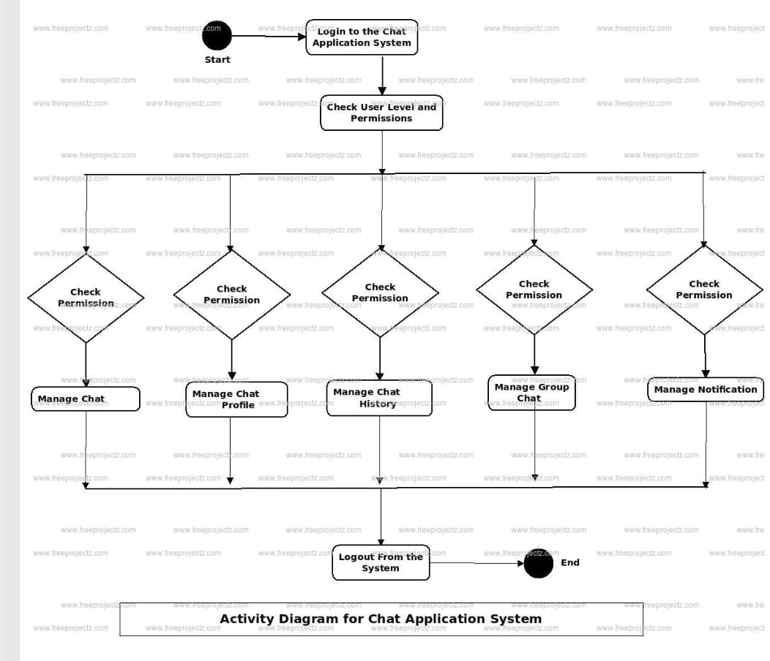

4.2 Class Diagram

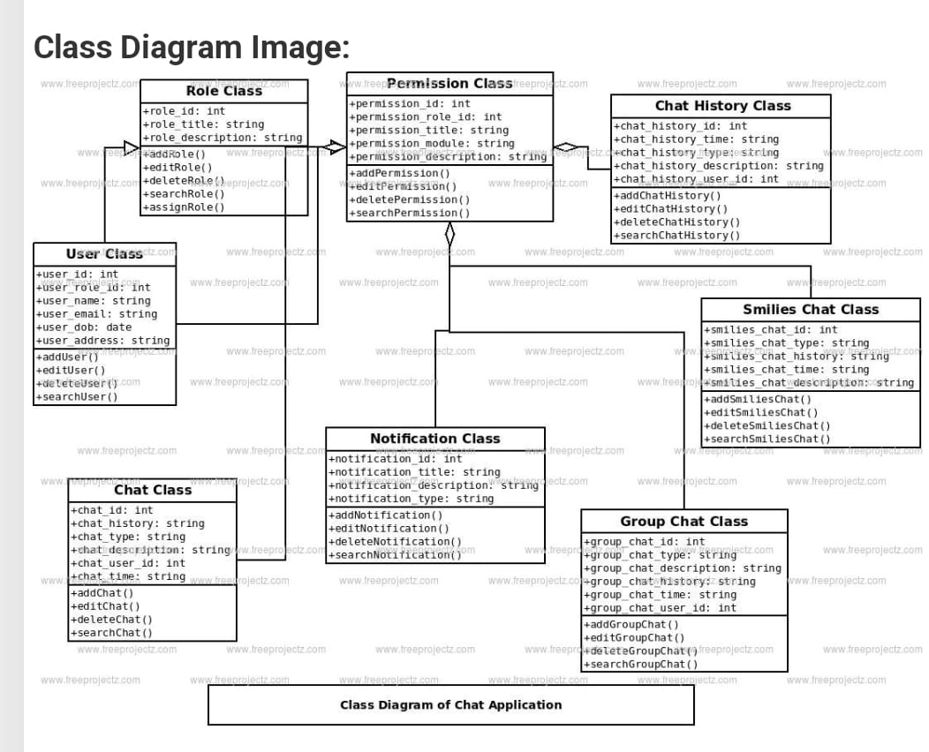

4.3 Component Diagram

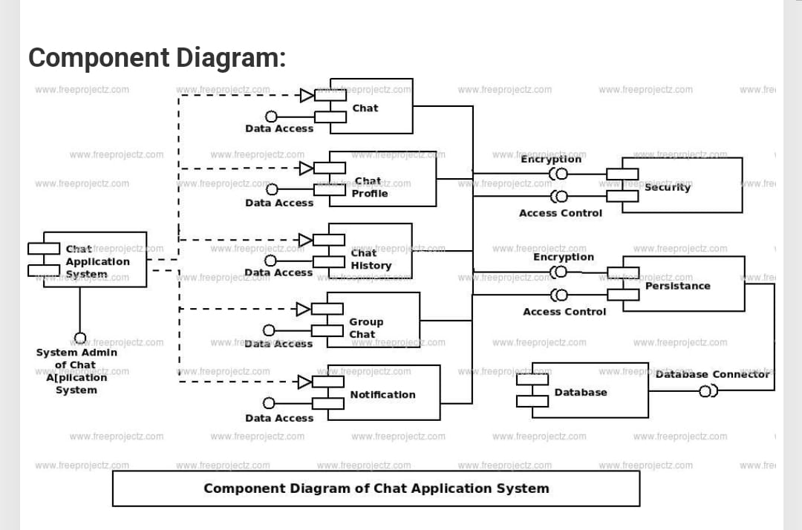

4.4 Sequence Diagram

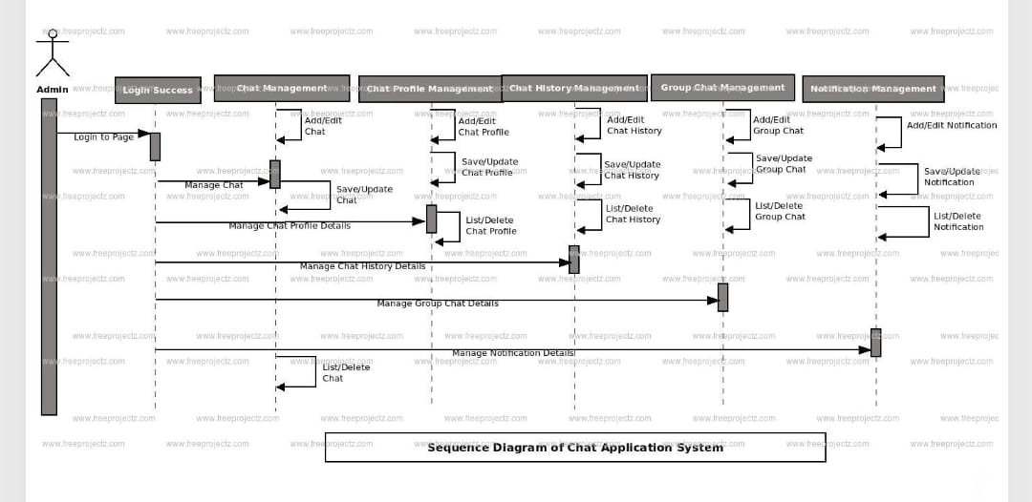

**CHAPTER-5**

**IMPLEMENTATION**

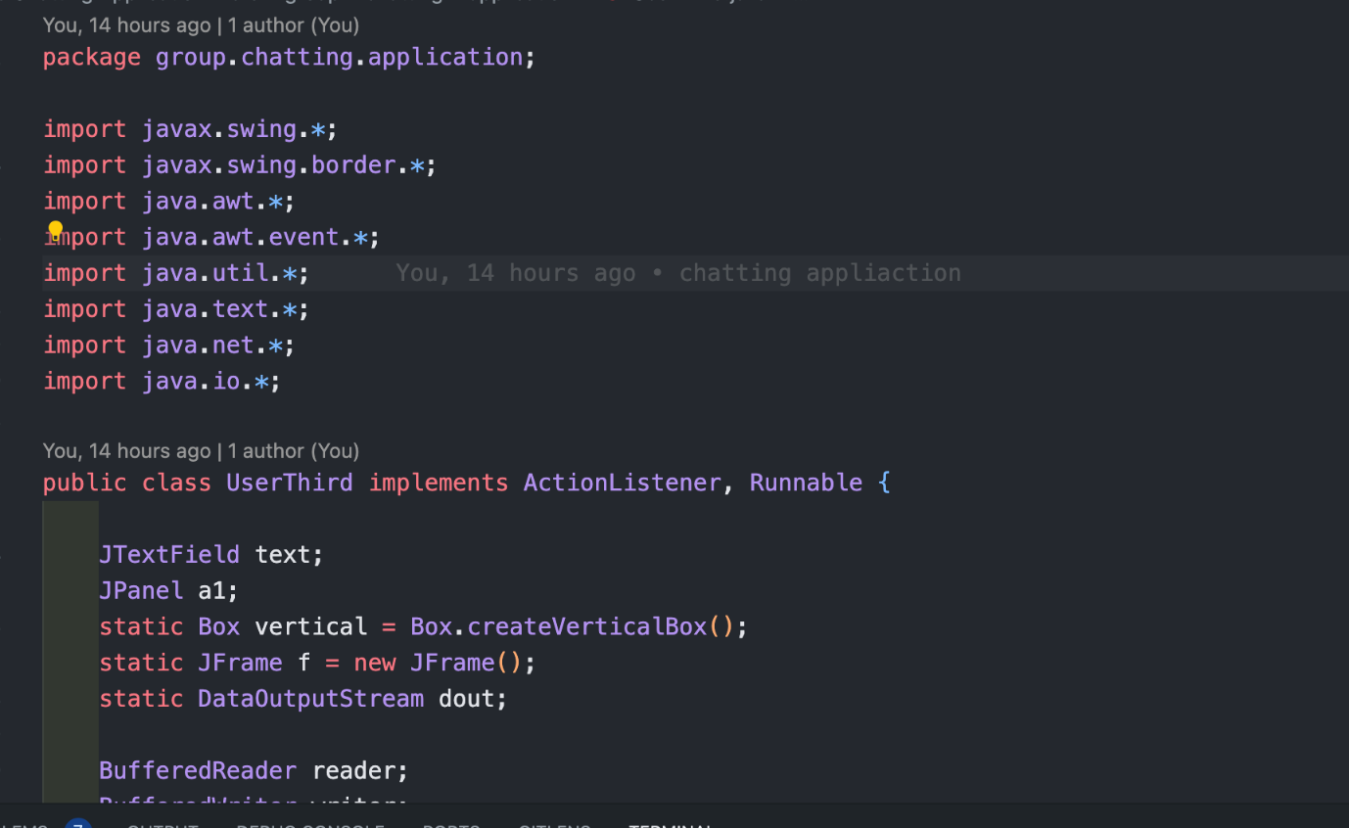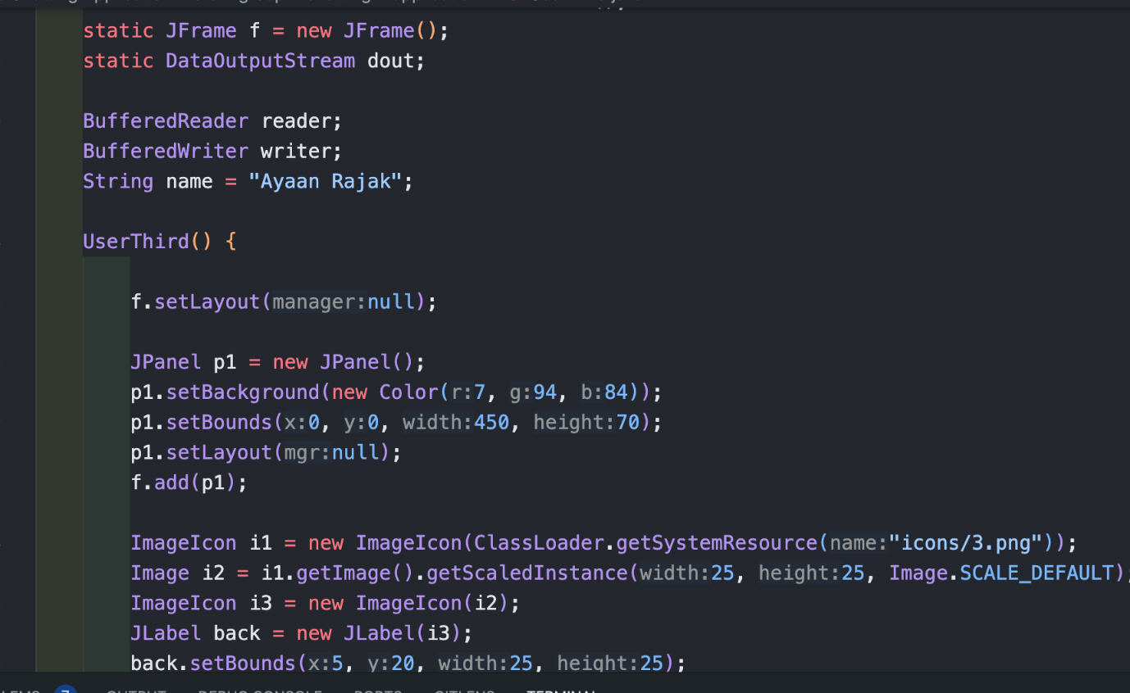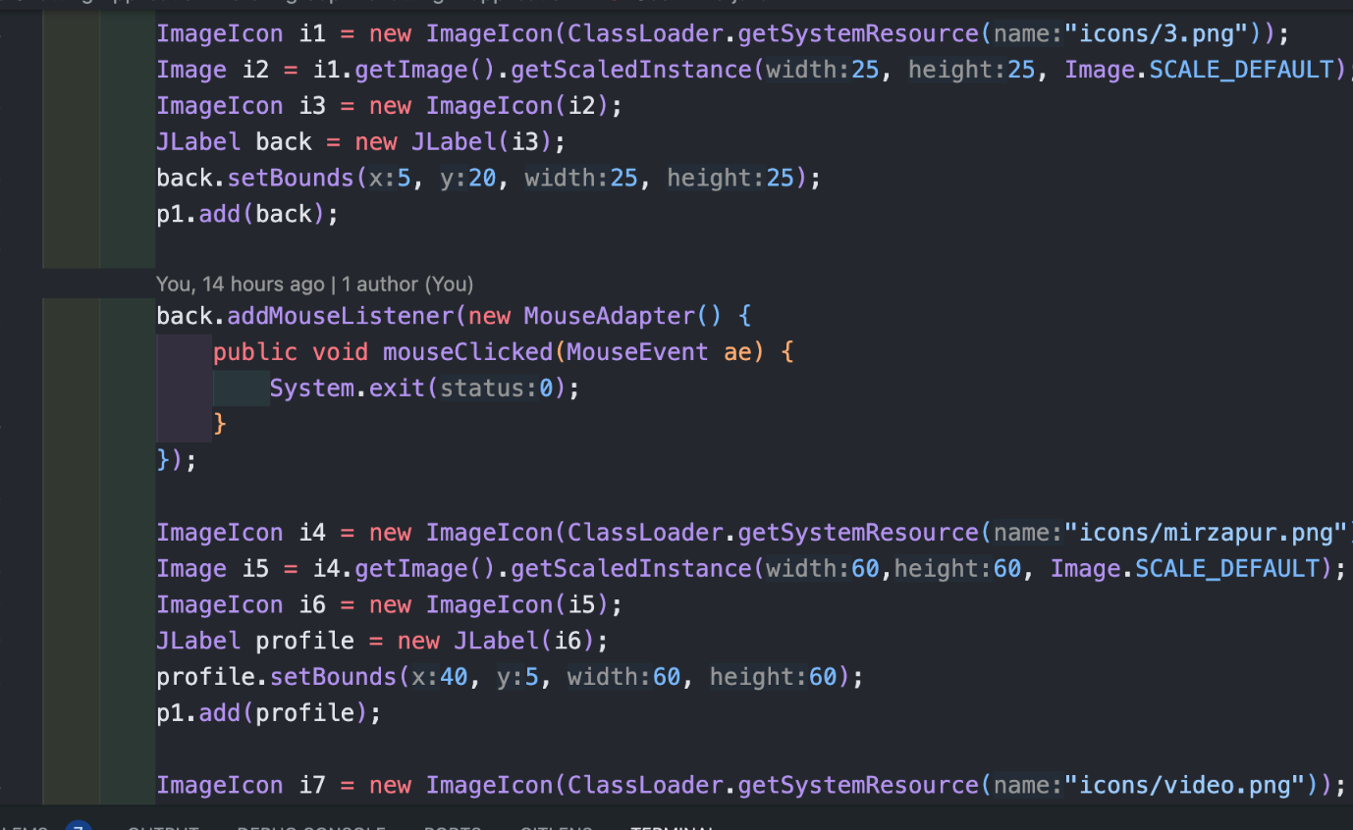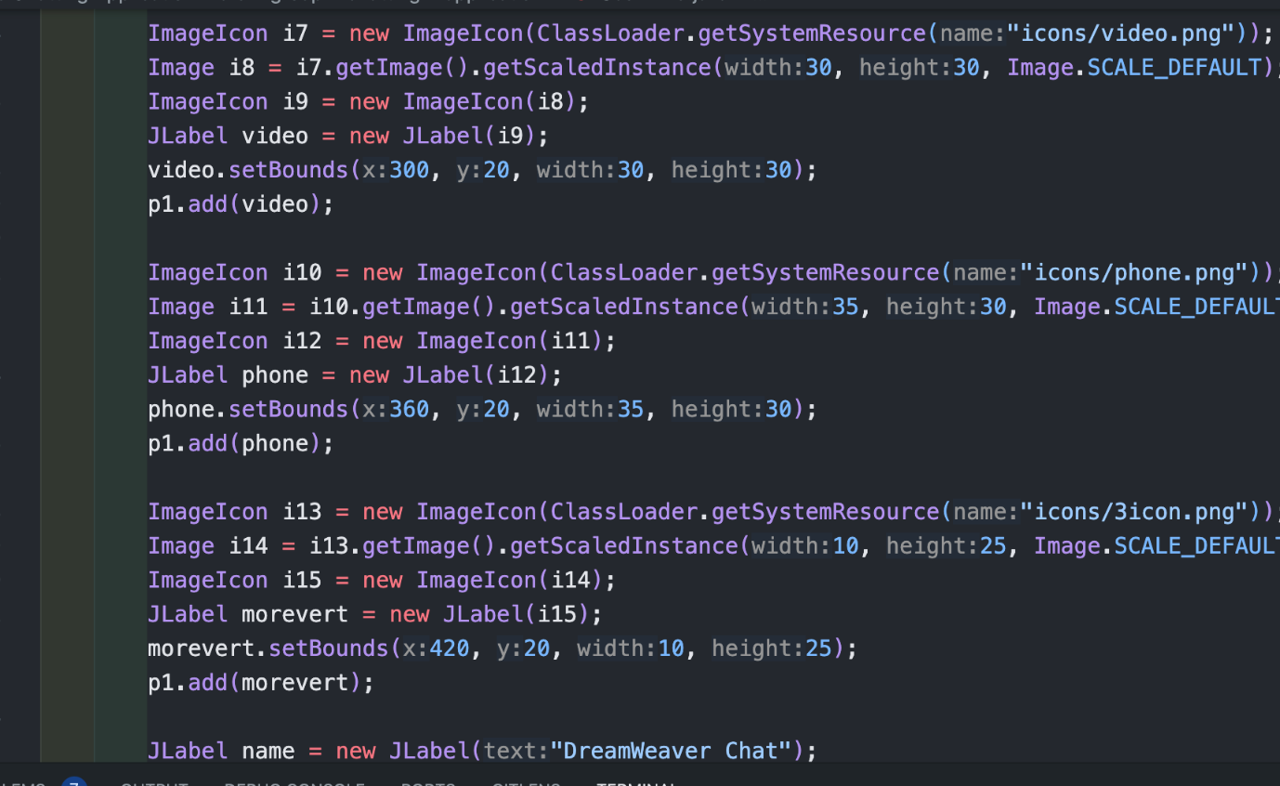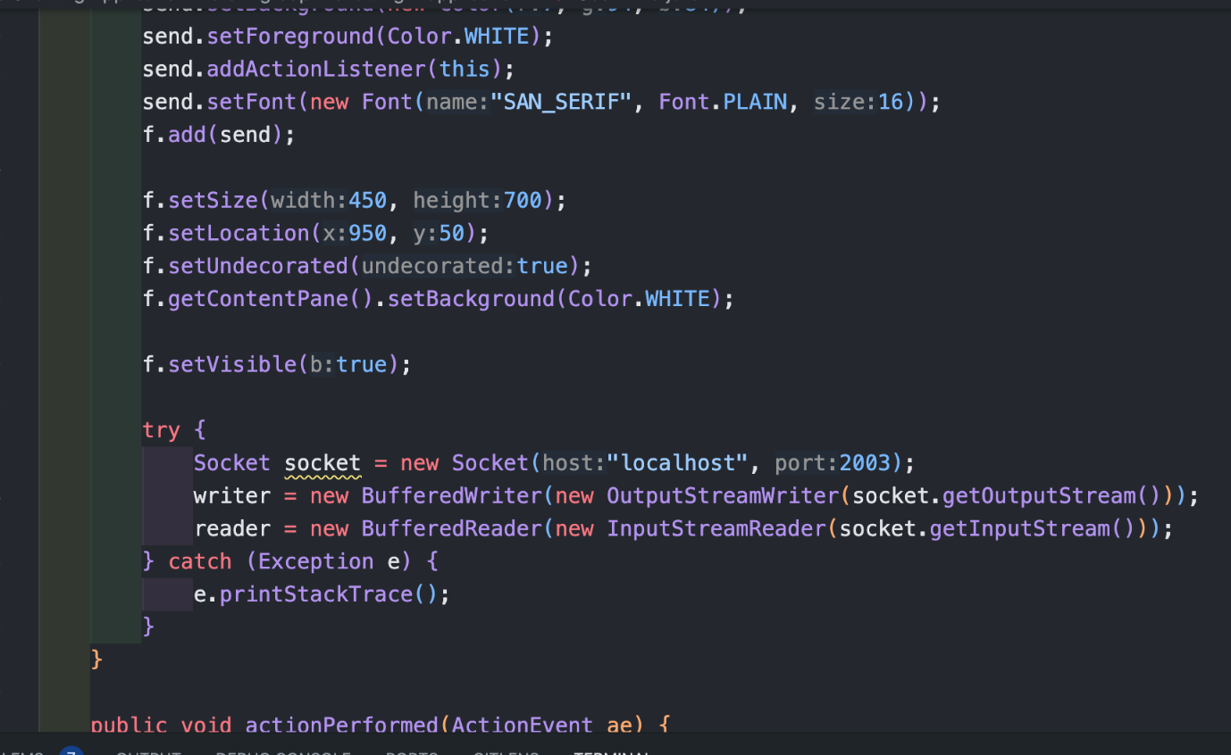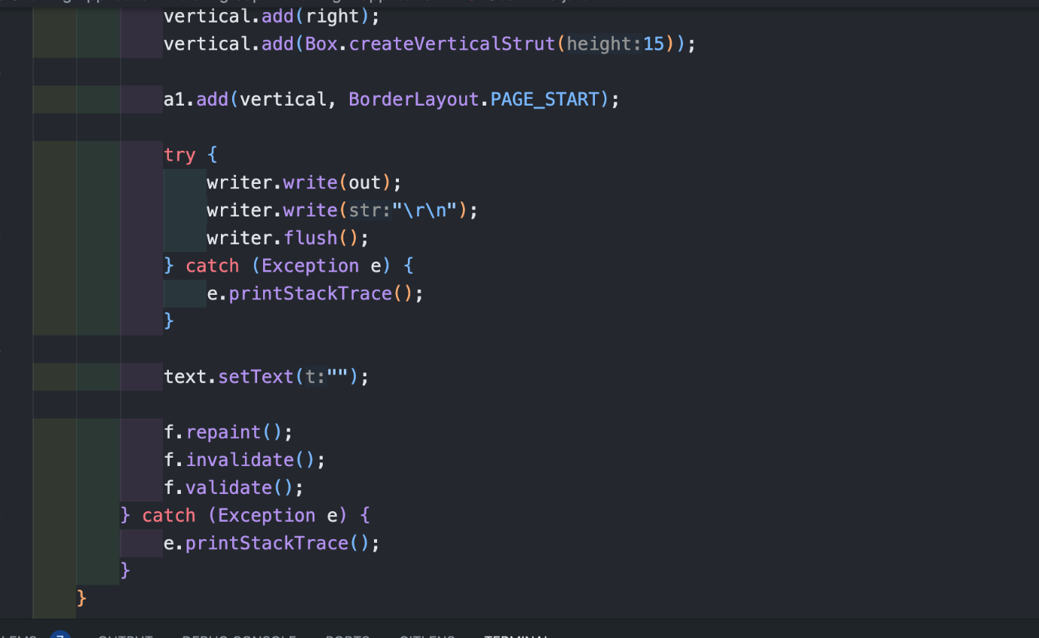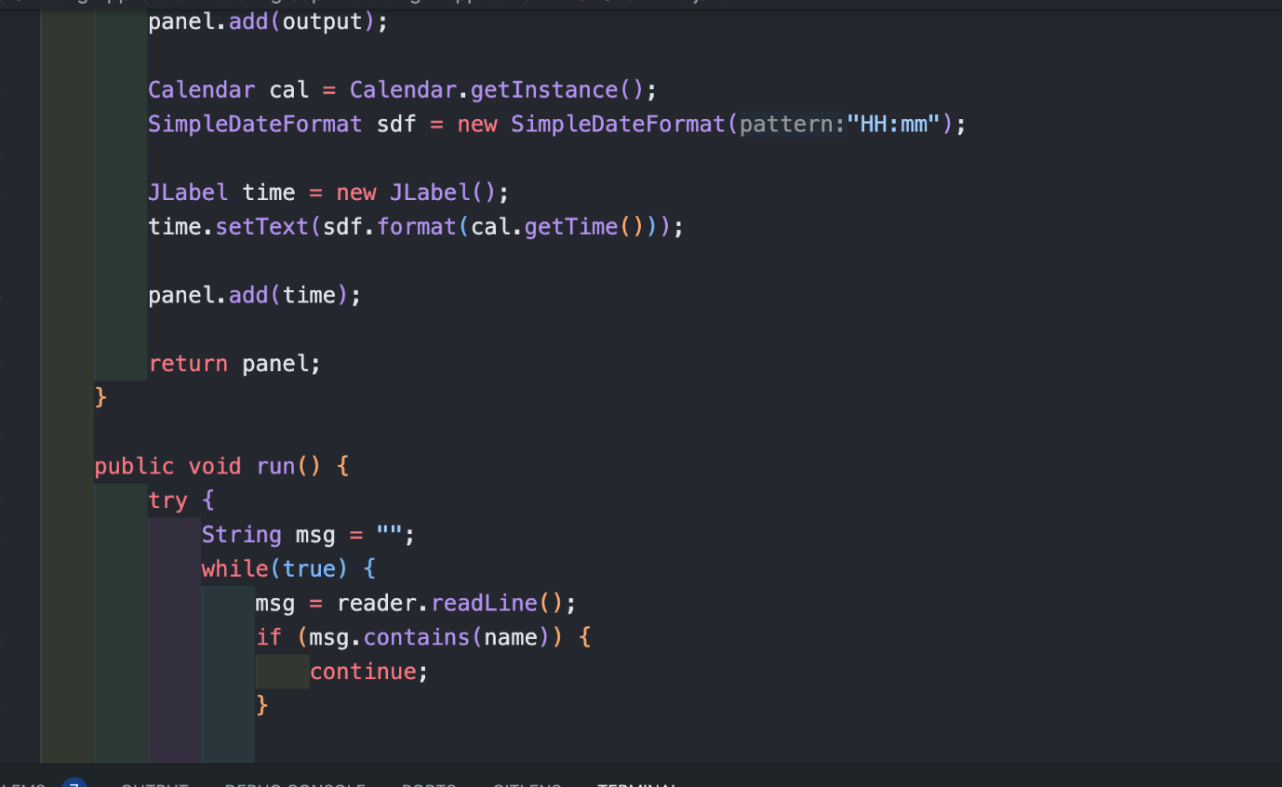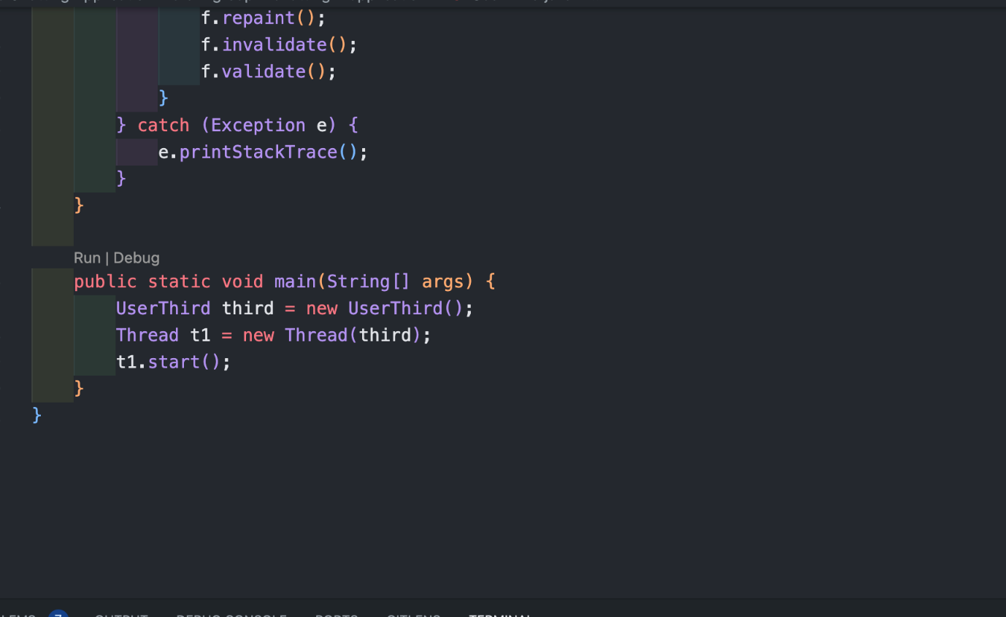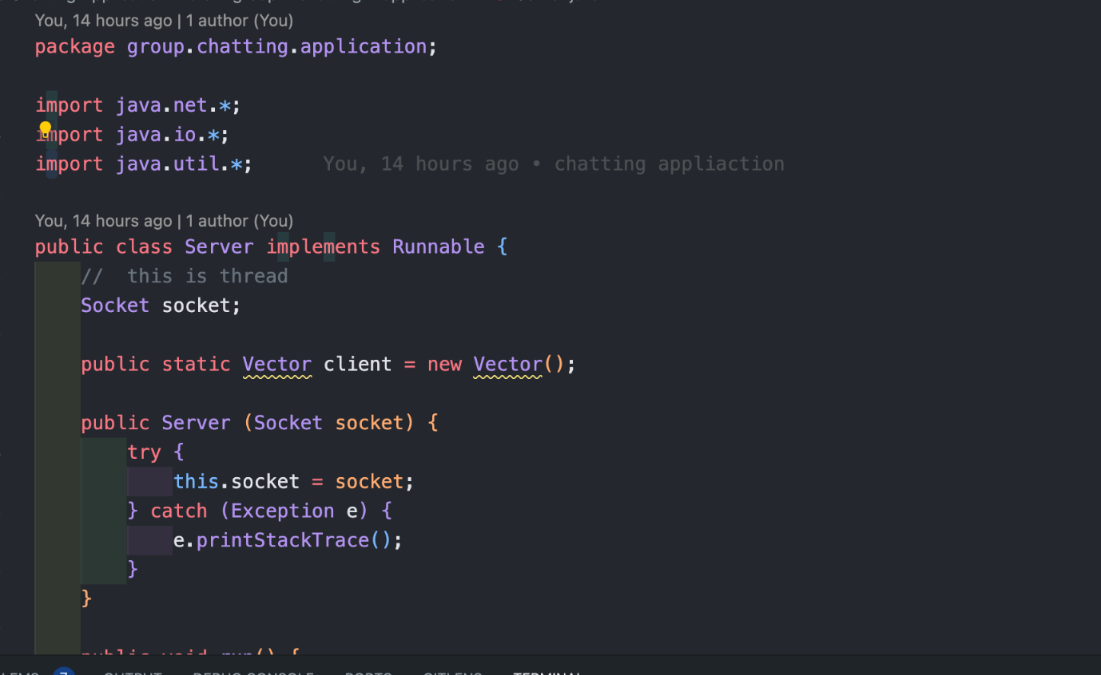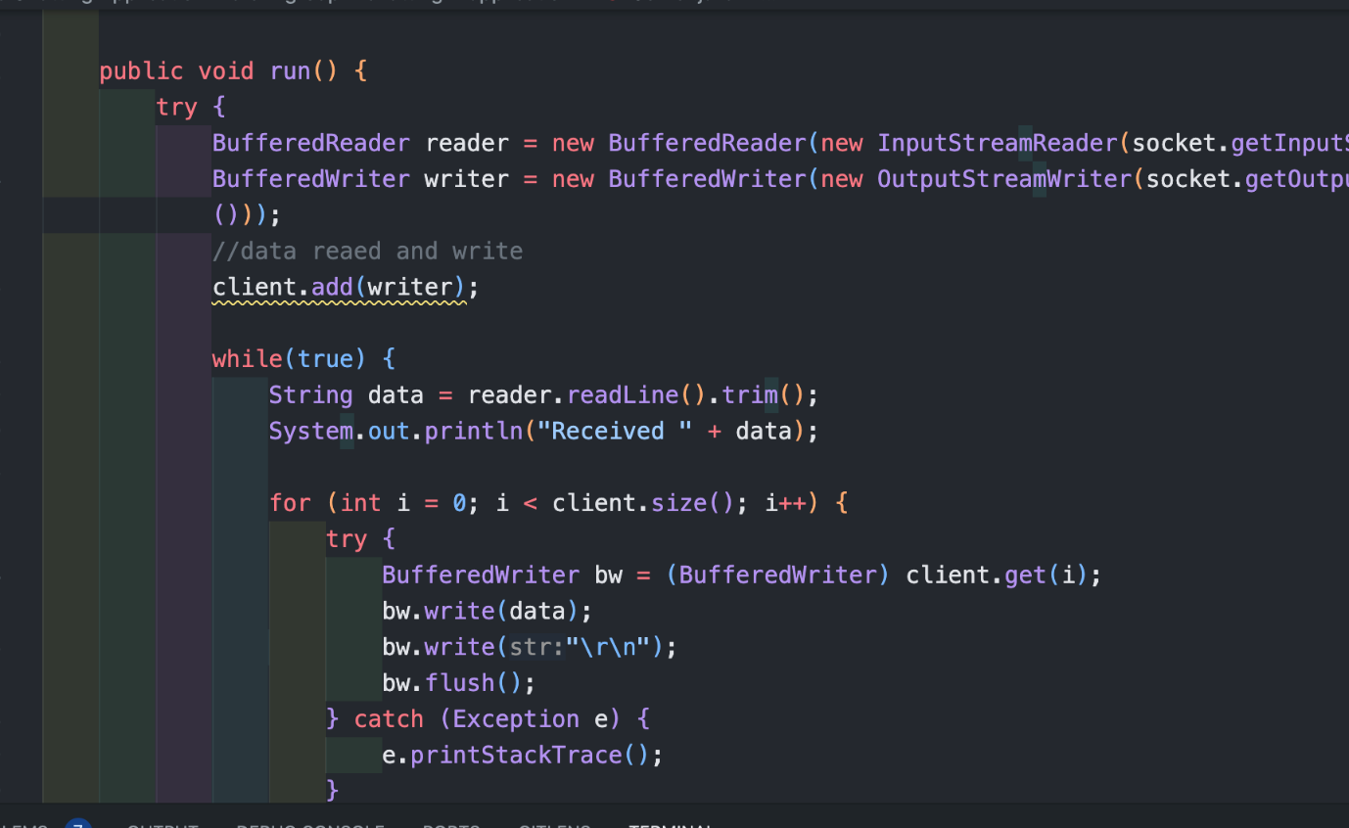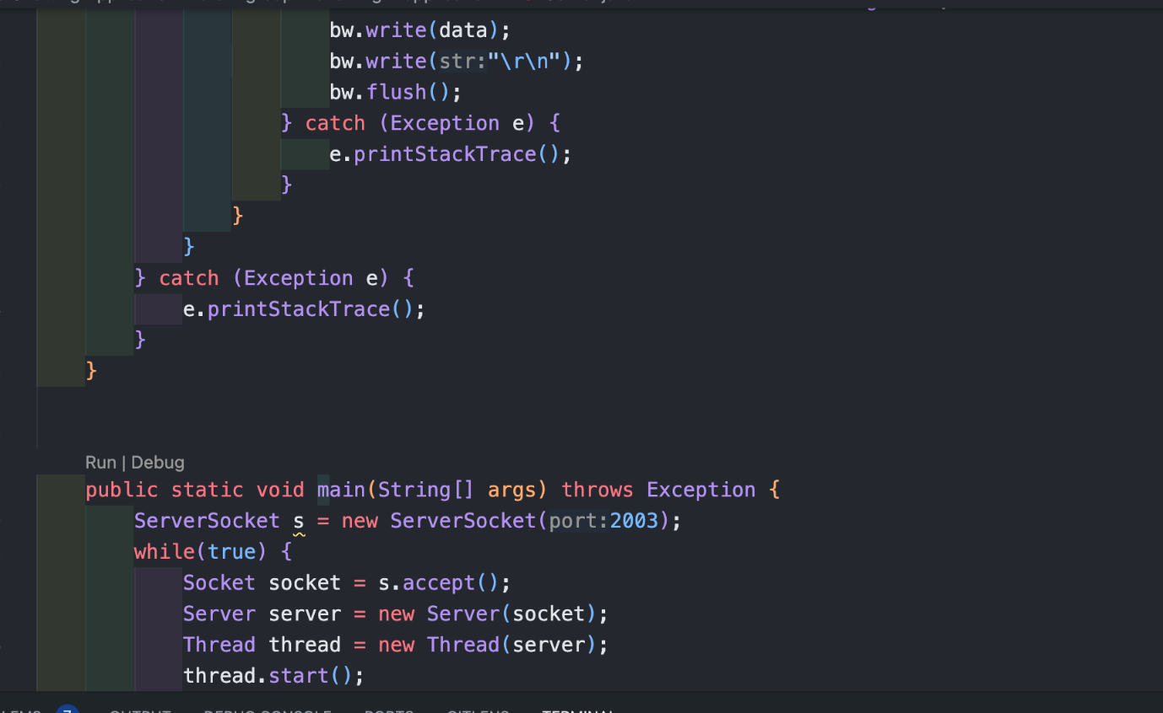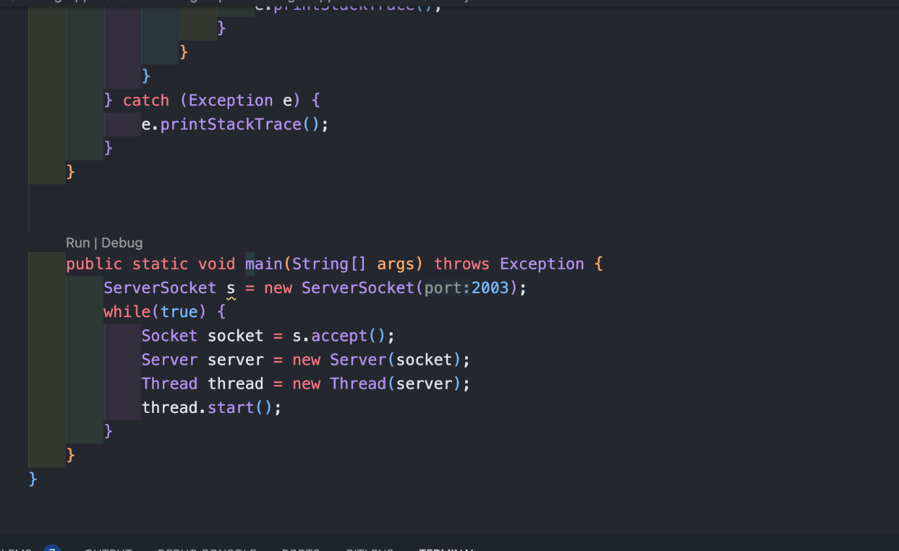

**CHAPTER-6**

**RESULTS AND DISCUSSION**

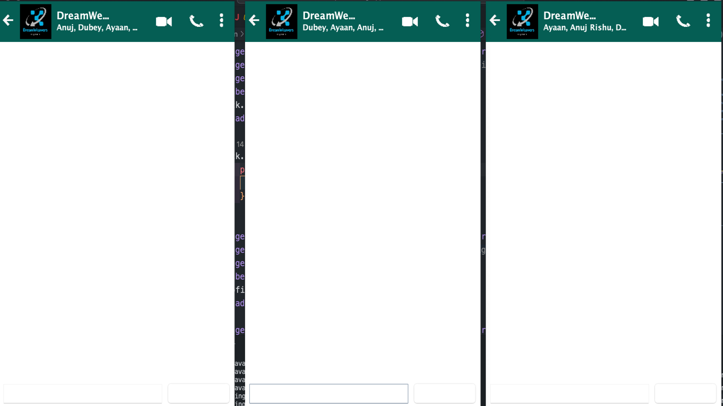

**CHAPTER-7**

**CONCLUSION**

The development of the Group Chat Application represents a significant milestone in modern communication technology, providing users with a versatile and user-friendly platform for real-time group interactions. The project successfully achieved its objectives, offering a feature-rich application that enhances communication, prioritizes user experience, and ensures security and privacy.

One of the project's key achievements is the enhancement of communication dynamics. The instant messaging feature facilitates seamless conversations among users, fostering collaboration and connection. The application's design, centered around user needs, ensures an intuitive interface that enables easy navigation and engagement with various features.

Security and privacy were paramount considerations during the development process. The implementation of end-to-end encryption ensures that user messages are secure, instilling confidence and trust in the application's reliability. This commitment to data protection aligns with contemporary standards and addresses users' concerns regarding privacy in digital communication.

Scalability and performance were critical aspects of the project. The application was designed to accommodate a growing user base without compromising responsiveness. This scalability ensures that the application remains effective even with increased usage, catering to diverse user requirements.

The cross-platform compatibility of the application is another noteworthy accomplishment. Users can seamlessly connect across different devices and operating systems, contributing to the application's versatility and accessibility. This inclusivity aligns with the diverse technological landscape and allows users to engage with the application using their preferred devices.

Innovation played a crucial role in the project's success. The incorporation of features such as multimedia sharing, robust group management, and an efficient notification system adds richness to the user experience. These features address the varied needs of users and contribute to the application's competitive edge in the communication technology landscape.

In conclusion, the Group Chat Application stands as a testament to the dynamic nature of modern communication solutions. Its success lies not only in meeting technical requirements but also in creating a digital space where users can connect, collaborate, and share experiences securely and innovatively. As technology continues to evolve, this application serves as a beacon, showcasing the possibilities of enhanced, secure, and inclusive group interactions.

**CHAPTER-8**

**REFERENCES**

1. https://www.ijeat.org/wp-content/uploads/  
 papers/v9i5/E9578069520.pdf

2. http://indusedu.org/pdfs/IJREISS/  
 IJREISS_3661_55346.pdf

3. <https://thescipub.com/pdf/jcssp.2015.723.729.pdf>

4. https://www.ijrte.org/wp-content/uploads/  
 papers/v7i5s2/ES2063017519.pdf

5. https://core.ac.uk/download/pdf/187726106.pdf